The DMT Mandala
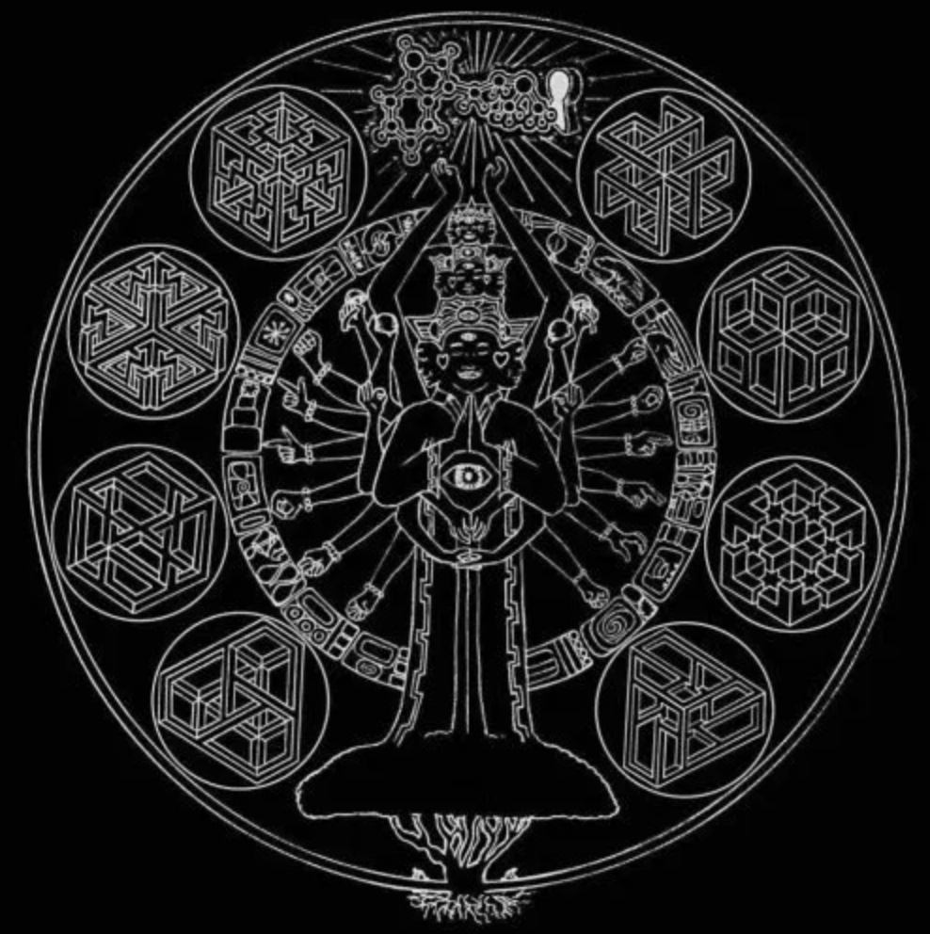

Illustration of the DMT Mandala shows the Spirit of the Mimosa Hostilis Tree. You can see the Spirit rising from the top of the Tree. At the base of the Tree – 2 Shamans ethically harvest only the lateral roots of the Tree. The Spirit has 12 hands with bracelets. Using American Sign Language these 12 hands spell out; “All One Source”. He is holding 2 mushrooms which are Psilocybin, also known as 4-HO-DMT, or 4-hydroxy-N,N-dimethyltryptamine. So this is a tip of the cap to the Fractal Nature of DMT to occur in different forms and totally different biological structures (mushrooms/plants).
The circle of 16 Mayan-inspired panels that his hands are pointing to describe in great detail the path from the Germination of the Mimosa Seed, all the way through an Extraction and Recrystallization of DMT. As you complete the Circle you are brought finally to the Molecule itself, raised above the hands of the Spirit, Radiating. The Keyhole to Imagination is marked with undecipherable and forgotten Sacred text, all the way around. The 12 hands with bracelets represent the 12 carbon atoms of the DMT Molecule. The 16 panels that the hands are pointing to represent the 16 hydrogen atoms, and finally the two Spheres held in the hands of the Spirit, represent the 2 nitrogen atoms; to complete the DMT Molecule.

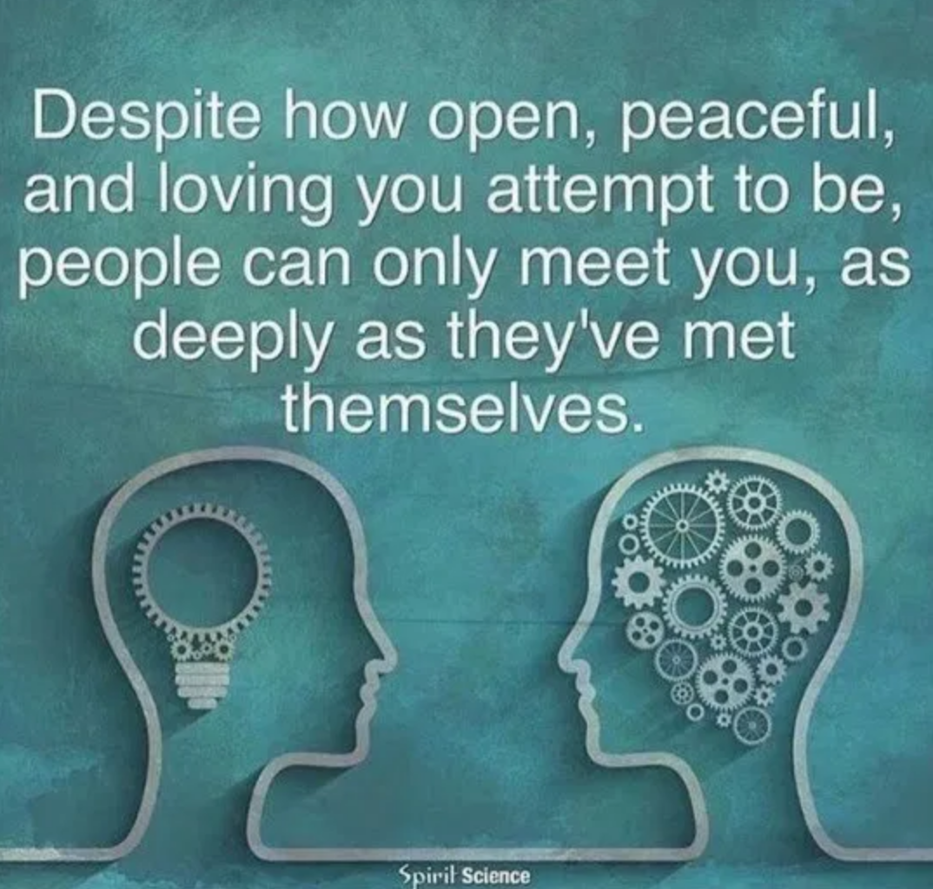

For more visit: Tantric Journeys TUMBLR

